# Friday, February 06, 2015 FHIM Modeling Call

Attendees:

* Steve Wagner
* Galen Mulrooney
* Ioana Singureanu
* Susan Campbell
* Susan Matney
* Jay Lyle
* Rob McClure
* Loren Stevenson
* Huma Munir
* Sean Muir
* Tosh Kartchner
* Robert Crawford
* Raisa Ionin
* Robert Crawford

Announcements/Updates

Coming up on Tuesday Feb, 10th at 1 pm FHIM Information Modeling Call

This follow meeting will allow us to the interest and needs of HL7 FHIR, federal partners (SAMHSA, VA). Looking to define what are the plans to adopt or implement FHIR re: CQF, SDC, DAFD or other initiative producing FHIR profile definitions.

* Modeling Care Plan during the FHIM Friday call at 2:30pm
* Terminology Modeling Pharmacy on Wed at 2pm
* Mapping the FHIM to new standards definitions from SDC, DAF, and CQF
* ELTSS S&I Initiative is a community driven initiative. Alberto and Susan Campbell are following this initiative. The scope of work has been defined. ELTSS 🡪Resources link point to the latest presentation of scope. Action: send a note the project managers of the ELTSS initiative to find out if they are planning to adopt the Use Case modeling tools define/identified by S&I Simplifcation.
* Pharmacy vocabulary harmonization on-going during the Wednesday call. Vital signs qualifier codes may be added to LOIN after the federal partners have a change to review this. Clem McDonald requested additional information on the FHIM vitals to help support these new changes.
* Monday and Tuesday this week ONC Annual Meeting
  + Theme: CMS has announced their 50% of reimbursement will target alternative payment models (e.g. ACOs) other than fee for service. This percentage will grow over time.
  + Theme: Precision/personalized medicine (genomics)
  + These themes require interoperability and health IT
  + New document: Health Standards Advisory that lists standards and under which
  + Health IT Strategic Plan
  + FHA interoperability plan is going forward
  + There was a breakout session re: DIRECT, CONNECT, and FHA/FHIM

Modeling session stated at 2:54

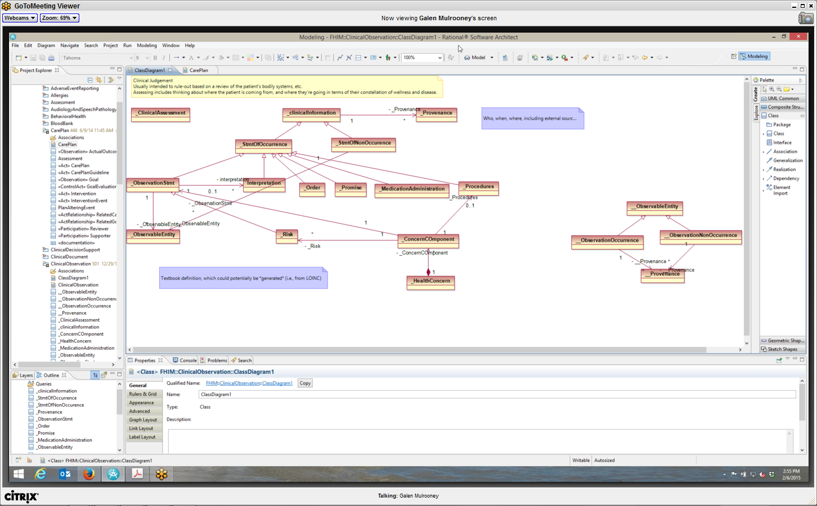

Refactoring observation classes. QA DAM used observation to model events planned, never occurred, occurred. FHIM does not use multiple

StatementOfOccurrence or StatementOfNonOccurrence are used to facilitate the use of the clinical data by rules engines. Observation with context allows us to use a coded SNOMED-CT attribute to specify the exact statue of a “ClinicalStatement”.

Observable Entity (the “textbook definition”) may be further refined as a DCM/CIMI model to describe a specific observable thing (e.g. based LOINC). The Entity may be associated with and ObservationStatement.

Data Provenance is required on Observation but also orders, promises and interpretations.

Rob suggested that interpretations, statements, etc, are all types of observations. We could separate the interpretation associated with the observation or we could add another observation.

Susan Matney indicated that LOINC is working on a way to make “within defined limits” a more consistent set of observations associate with an “impression” (e.g. for skin to say “within defined limits” implies a color, temperature, etc. of the skin and we need three separate measurements, similarly WDL for lungs would imply another set of findings).

A context may be required to better understand an observation. For instance a immunization can account for the lack of vesicles in a Varicella Zoster presentation and a prior bout of flu can help in diagnosis.

Epistemological /(human reasoning) or ontological (relationship based) view of context distinguishes.

Statements of non-occurrence allows nurses to chart “by exception” rather that SOAP. “not done” vs. “not found” may be addressed using sub-classes or a context attribute. Associating interpretations with observation may be appropriate if we stereotype the <<interpretation >> stereotype. Diagnoses may be associated with assessments.

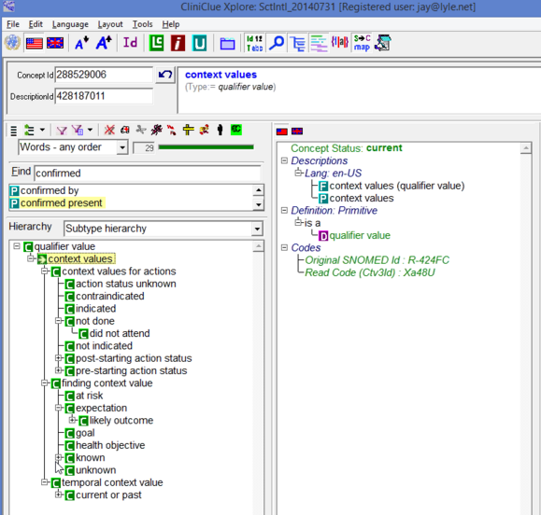

Galen is advocating that FHIR maintain a “status” of the record similar to the V3 status and add a domain-specific status (e.g. refute). Contextual modifier e.g. “known to be absent” may be used. SNOMED allows for additional qualifiers.

Observable entities may have a result and associated LOINC test. Subjective vs. Objective observation are typically based on provenance (objective: provider. Subjective: everyone else).

Next week’s agenda:

Care Plan modeling

Susan Matney will be attending the LOINC meeting next week.,